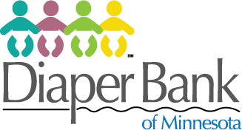

1/3 of Minnesota babies and toddlers don’t have enough clean diapers. You can help!

Collection Site
Diapers
Wipes

The Diaper Bank of Minnesota is a 501(c)(3).
Donations are tax-deductible.

Financial donations may be made at www.diaperbankmn.org

